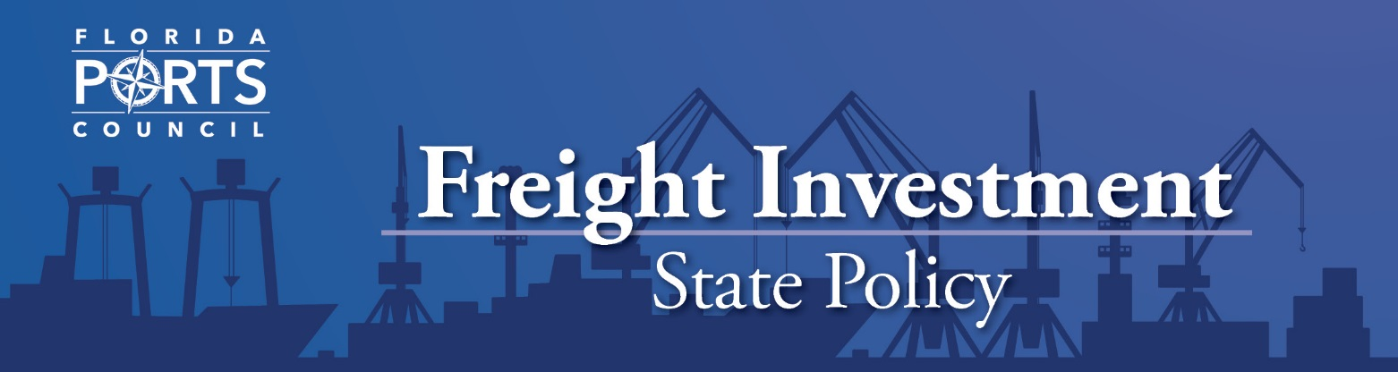

Background:

Our nation’s seaports and harbors are gateways to domestic and international trade. More than 90 percent of the U.S. foreign trade moves through our nation’s 300 seaports, representing 25 percent of the U.S. Gross Domestic Product. In Florida alone, this waterborne trade represents $117.6 billion in total economic activity and generates more than 900,000 direct and indirect jobs. There has been a significant level of discussion and improvement concerning freight infrastructure funding on a federal level, including the creation and funding of the TIGER grant funding program. These federal programs, combined with freight mobility investments by Florida, have enabled our seaports to improve services to the Southeastern region of the U.S. and the world.
Recommendations:

The Army Corps has not released their 2018 Work Plan to date. The Florida Ports Council recommends an appropriate allocation of funds for identified and approved construction and maintenance/operation projects in Florida. This includes a continuation of funds for unfinished projects funded in the Corps’ 2017 Work Plan.

The Florida Ports Council recommends at least 25 percent of TIGER grants be awarded to
port-related infrastructure projects.

The Florida Ports Council supports the full utilization of the Harbor Maintenance Trust Fund (HMTF) for Congressionally approved harbor navigational and maintenance projects. We recommend a review of how to ensure the “full” use of HMTF funds for approved projects by congressional appropriators.

Current Issue:

Florida has invested more than $1.5 billion in freight infrastructure at its seaports over the last eight years. An additional $600 million was proposed in the Florida Department of Transportation’s five-year Seaport Work Program. The total five-year Florida Seaport Capital Improvement program, including both state and local funding, is over $3.3 billion.

The Transportation Investment Generating Economic Recovery (TIGER) Grant Program provides grants for investment in road, rail, transit and port projects that promise to achieve critical national objectives. This program was one of the first federal programs to invest in port-related infrastructure. The 2018 omnibus appropriations bill provided $1.5 billion for these discretionary grants.

The 2018 omnibus bill also increased funding for identified U.S. Army Corps projects. The bill provides $3.07 billion for navigation projects and studies, including $1.4 billion from the Harbor Maintenance Trust Fund (HMTF).The bill includes authorization for (6) six new study starts and (5) five new construction starts.

Florida has two deepening construction projects on the east coast and several maintenance and operations projects around the state – including ongoing Everglades restoration.

florida ports council
(850) 222-8028 · info@flaports.org
www.flaports.org

