April 20, 2014

Members of Florida Senate

Florida Senate

222 Senate Office Building

404 South Monroe Street

Tallahassee, FL 32399-1100

Dear Senator,

Thank you for your continued support of Florida’s seaports. Under the leadership of this Legislature, Florida has begun the process of making Florida the global gateway for international commerce. With more than 680,000 jobs supported by maritime activities at our state’s 15 seaports – this Legislature has made investing in strategic infrastructure projects at Florida's ports a top priority.

When these investments are coupled with investments in Florida’s freight mobility network – road, rail, airports and seaports – Florida will stand out as America’s gateway to the Caribbean, Latin America and beyond. Jobs and commerce once destined for other parts of the U.S. and the Caribbean are now expanding or locating in Florida.

We need to continue investing in our freight mobility priorities. HB 5601 provides for an additional annual investment of $85 million “for transportation projects within this state for existing or planned strategic transportation projects that connect major markets within this state or between this state and other states, focus on job creation, and increase this state's viability in the national and global markets.”

**We urge you to support and pass this language in HB 5601 to help create the infrastructure in Florida that will support thousands of jobs for Floridians involved in the movement of freight, goods, and people.**

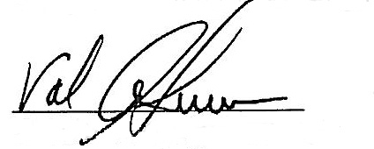Respectfully,

___________________________

Val Schwec, Florida Ports Council Chair Doug Wheeler, President and CEO

Port of Fernandina Florida Ports Council

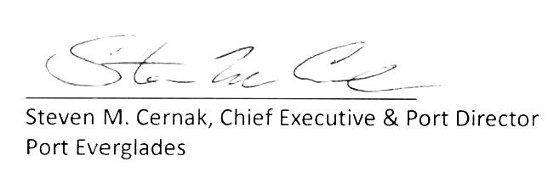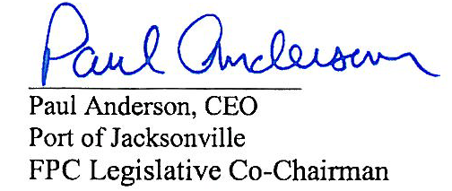

____________________________

Paul Anderson, FPC Legislative Co-Chair Steven Cernak, FPC Legislative Co-Chair

Tampa Port Authority Port Everglades

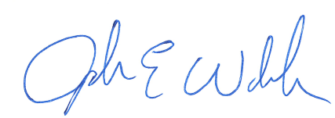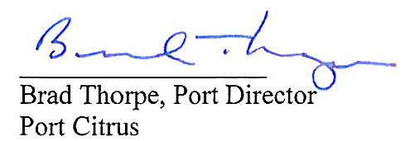_____________________

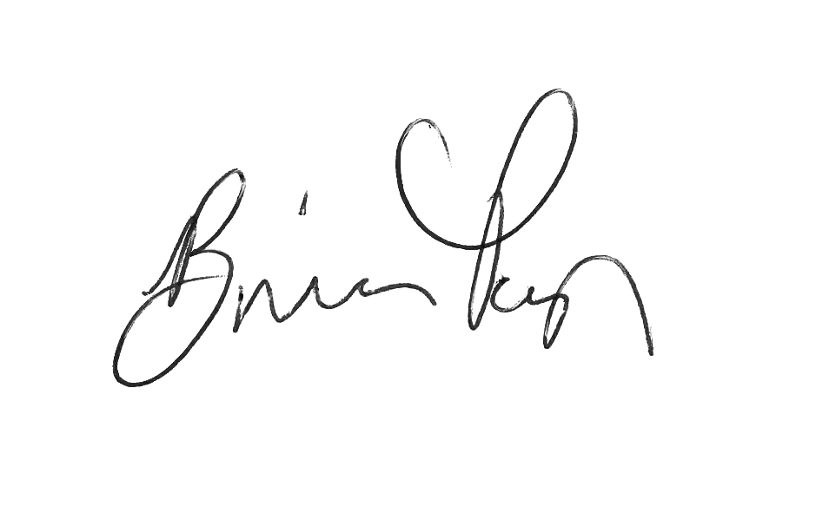John Walsh, CEO

Port Canaveral



_________________________

Don West, Port Director Brian Taylor, CEO

Port of Ft. Pierce JAXPORT



_________________________

Doug Bradshaw, Director Carlos Buqueras, Port Director

Port of Key West Port Manatee

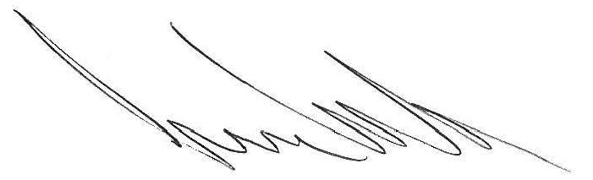

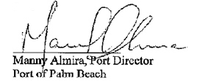

_________________________

Juan Kuryla, CEO  
PortMiami

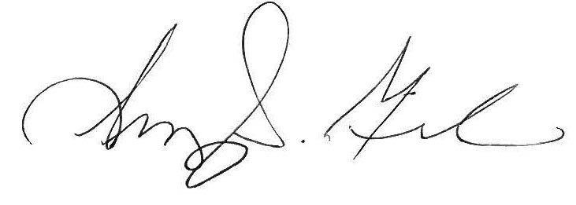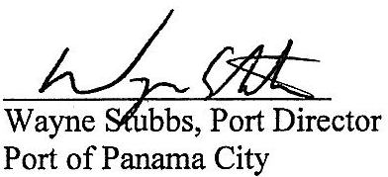

__________________________

Amy Miller, Port Director

Port of Pensacola

